COVID-19 in Athens, GA, USA 2020-2021

Cody Dailey [1]

22 November 2021

Table of Contents

# 1 COVID-19 Epidemic Curve in Athens

Figure 1.1 shows the epidemic curve for Athens-Clarke County with cases by dates of report and symptom onset, and PCR positive tests by date of specimen collection. These data are complete from 01 February 2020 to 08 February 2021 and have records for cases totaling 1.1468^{4}, 1.1451^{4}, and 1.1821^{4}, respectively for cases by report date, symptom onset date, and date of specimen collection.

The difference in the curves is slight, but left shifts are notable. That is, the curve for cases by report date lags behind the curve for PCR positive cases by date of specimen collection which, in turn, lags behind the curve for cases by symptom onset date.

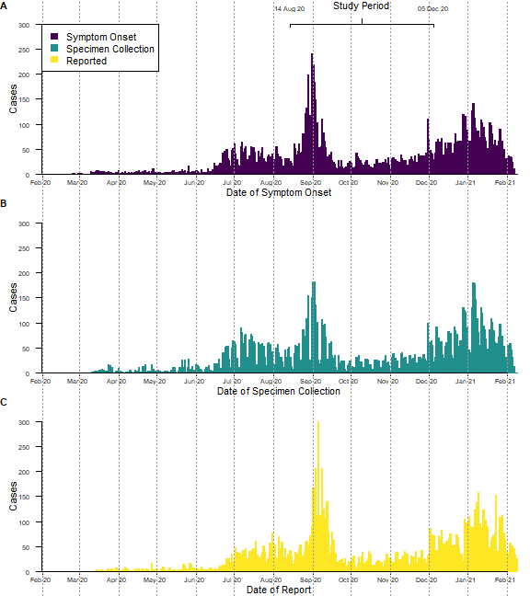

Figure 1.1: Epidemic Curve of COVID-19 in Athens-Clarke County, GA, USA

1. Department of Epidemiology and Biostatistics, University of Georgia, Athens, GA, USA